**Advanced Database Management Systems**

**Experiment-8**

**To understand the concepts of Sequence**

**Aryan Mohan**

**500092142**

**Batch- 2**

create database LabExperiment8;

USE LabExperiment8;

CREATE SCHEMA EMPLOYEE ;

CREATE SEQUENCE EMPLOYEE.EMPID_SEQ START WITH 100 INCREMENT BY 1 ;

--Write a SQL command for finding the current and the next status of EMPID_SEQ.

SELECT NEXT VALUE FOR EMPLOYEE.EMPID_SEQ;

Output:







--Change the Cache value of the sequence EMPID_SEQ to 20 and maxvalue to 1000.

ALTER SEQUENCE EMPLOYEE.EMPID_SEQ RESTART WITH 500 INCREMENT BY 5 MINVALUE 50 MAXVALUE 1000 CYCLE CACHE 20;

SELECT NEXT VALUE FOR EMPLOYEE.EMPID_SEQ;

Output:



--4) Insert values in employees table using sequences for employee_id column.

CREATE SCHEMA TEST;

CREATE TABLE TEST.EMPLOYEE( EMPID INTEGER PRIMARY KEY, ENAME VARCHAR(30), JOB VARCHAR(20), MGR INTEGER, HIREDATE DATE, SAL INTEGER, COMM INTEGER, DEPTNO INTEGER );

CREATE SEQUENCE TEST.emp_id START WITH 1000 INCREMENT BY 1 ;

INSERT TEST.EMPLOYEE (EMPID, ENAME, JOB,MGR, HIREDATE,SAL,COMM,DEPTNO) values (NEXT VALUE FOR TEST.emp_id, 'ALLEN','SALESMAN', 7698,'20-FEB-81',1600,300,30);

SELECT * FROM TEST.EMPLOYEE;

INSERT TEST.EMPLOYEE (EMPID, ENAME, JOB,MGR, HIREDATE,SAL,COMM,DEPTNO) values (NEXT VALUE FOR TEST.emp_id, 'WARD', 'SALESMAN',7698, '22-FEB-81', 1250,500,30);

SELECT * FROM TEST.EMPLOYEE;

Output:

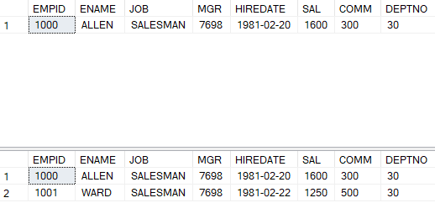

--Drop sequence EMPID_SEQ.

DROP SEQUENCE EMPLOYEE.EMPID_SEQ;

--Create a sequence called REVERSE to generate numbers in the descending order from 10000 to 1000 with a decrement of 5.

CREATE SEQUENCE TEST.REVERSE START WITH 10000 INCREMENT BY -5 MINVALUE 1000 MAXVALUE 10000 CYCLE CACHE 3;

SELECT NEXT VALUE FOR TEST.REVERSE;

Output:

